EXP 18

AIM: Design TM using simulator to accept the input string ww

INPUT:

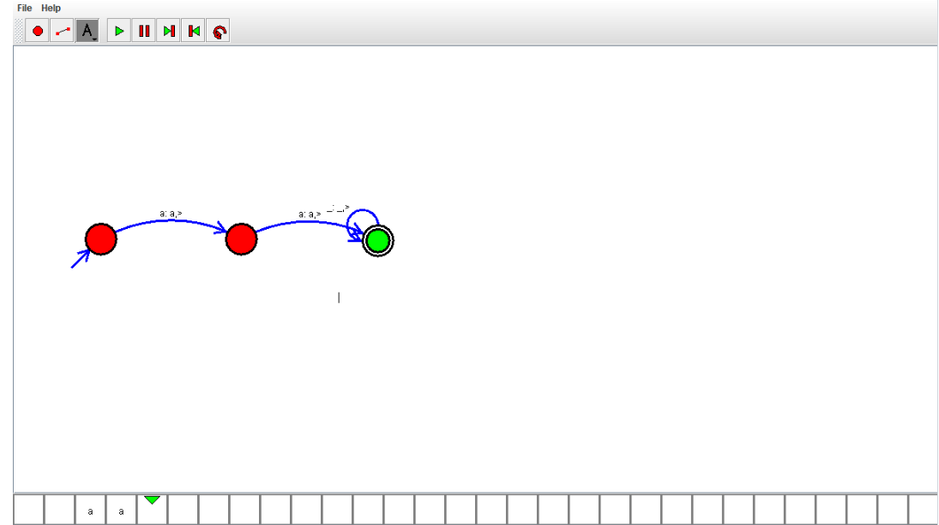

OUTPUT:



RESULT: TM using simulator to accept the input string ww Is verified